ΔΙΘΥΡΑ
Glycymeris americana: https://sketchfab.com/3d-models/bivalve-glycymeris-americana-pri-76898-c864fc85100c4dc9a493f527df7510bf
Ostrea sp.: https://www.digitalatlasofancientlife.org/vc/mollusca/bivalvia/pteriomorphia/
Chama crassa: https://sketchfab.com/3d-models/bivalve-chama-crassa-pri-44161-5c356ccc42064c7ea8cd0b91238d6a10
Nodipecten pernodosus: https://sketchfab.com/3d-models/bivalve-nodipecten-pernodosus-pri-44328-cd14b616da35470eae6894259697314c

ΓΑΣΤΕΡΟΠΟΔΑ
Turritella mortoni postmortoni: https://sketchfab.com/3d-models/gastropod-turritella-mortoni-postmortoni-pri-b8e3c783f0964d70b0f5542115ba6113
Busycon carica: https://sketchfab.com/3d-models/gastropod-busycon-carica-pri-76867-spec-3-ec0f80f5ee324f119e054dcb2c836b5b
Bayerotrochus teramachii: https://sketchfab.com/3d-models/gastropod-bayerotrochus-teramachii-pri-70103-b9df6a37d2d744d09eb0d7f2659682bc
Worthenia tabulate: https://sketchfab.com/3d-models/gastropod-worthenia-tabulata-pri-70108-5009e375cff7449cbfba677a5e722079

ΚΕΦΑΛΟΠΟΔΑ
Imitoceras rotatorium: https://sketchfab.com/3d-models/cephalopod-imitoceras-rotatorium-pri-44566-3bb4bf5373b54dffa725c972687230d1
Goniatites sp.: https://sketchfab.com/3d-models/goniatites-c2bdfa39825b44c0a5986025f43ef939
Gymnotoceras beachi: https://sketchfab.com/3d-models/cephalopod-gymnotoceras-beachi-pri-43629-6ee6a859053a4f7e87491057d334c86c
Ceratites depressus: https://sketchfab.com/3d-models/cmnh-11827-ceratites-depressus-philippi-aebd0d0cdfb8435db29aaa4868eddb5c

Cadoceras sublaevae: https://sketchfab.com/3d-models/cephalopod-cadoceras-sublaevae-pri-70580-ee1fe02196e94d0eb10701542d9b0cc1
Cleoniceras besairiei: https://sketchfab.com/3d-models/cephalopod-cleoniceras-besairiei-a478a7dd64cc43b4a542b1923c45e374

ΒΡΑΧΙΟΝΟΠΟΔΑ
Oleneothyris harlani: https://sketchfab.com/3d-models/brachiopod-oleneothyris-harlani-76901-e028148d788641109d4671811b7f9d34
Vinlandostrophia ponderosa: https://sketchfab.com/3d-models/vinlandostrophia-ponderosa-pri-70768-acf4e5e1155b41c6997f1aeb45adae5b
Mucrospirifer mrkonensis: https://sketchfab.com/3d-models/brachiopod-mucrospirifer-mrkonensis-pri-76891-a7f3c58b4b304257843a8c758281edf1

ΕΧΙΝΟΔΕΡΜΑ
Clypeaster reticulatus: https://sketchfab.com/3d-models/echinoid-clypeaster-reticulatus-pri-t-1818-3b11d54672ce4f678d2da42525fbafb3
Hemipneustes striatoradiatus: https://sketchfab.com/3d-models/echinoid-h-striatoradiatus-pri-42520-b6d0973a6c6a4e3fae2edd9fa4e1fb38
Strongylocentrotus purpuratus: https://sketchfab.com/3d-models/echinoid-strongylocentrotus-pri-78783-ff7eca213f1b4afcb22ec5457f244c1b
regular echinoid: https://sketchfab.com/3d-models/echinoid-regular-pri-76790-71ccb4e5a6b44a3d87043b7da9d24c1d
Actinocrinites gibsoni κρινοειδές: https://sketchfab.com/3d-models/crinoid-actinocrinites-gibsoni-pri-78779-23b51d9af0084d98b7246bb4e7579628
Agaricocrinus americanus κρινοειδές: https://sketchfab.com/3d-models/crinoid-agaricocrinus-americanus-pri-70601-2db9524514314cdcb82ca92dfd6f1dff

ΤΡΙΛΟΒΙΤΕΣ
Eldredgeops rana: https://sketchfab.com/3d-models/trilobite-eldredgeops-rana-pri-49811-c8660b8b14364e1d9ff19372fd5fa052
Asaphus intermedius: https://sketchfab.com/3d-models/trilobite-asaphus-intermedius-pri-76770-f6805d2d272e4be99c1e5915849fbc88
Dipleura dekayi: https://sketchfab.com/3d-models/trilobite-dipleura-dekayi-pri-68155-064e595dc6a147aca9cdeb8aa6494999
Eldredgeops crassituberculata σε συσπείρωση: https://sketchfab.com/3d-models/trilobite-e-crassituberculata-pri-49388-da7c87704c294d69b857c6e54530bfe0

ΣΠΟΝΔΥΛΟΖΩΑ
Merycoidodon culbertsoni https://sketchfab.com/3d-models/vertebrate-merycoidodon-culbertsoni-pri-50653-e2e8d9bb62804de79f7a71c68feb6523
Ursus spelaeus https://sketchfab.com/3d-models/ursus-spelaeus-cave-bear-lower-jaw-pri-50009-f8f81494d773464eb4af4c863a212ab9
Carcharocles megalodon https://sketchfab.com/3d-models/vertebrate-carcharocles-megalodon-pri-55188-06e0bef4795840b4b21d17e5f51f3140
Borealosuchus sternbergi https://sketchfab.com/3d-models/vertebrate-crocodile-jaw-pri-ea13cdfc024e47c4a3ef81c983e9fbe0

ΦΥΤΑ
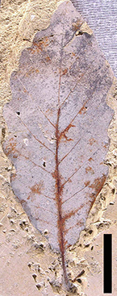
Quercus pseudocastanea
Πιτσίδια Ηρακλείου Κρήτης
Ανώτερο Μειόκαινο
Η κλίμακα αντιστοιχεί σε 1cm

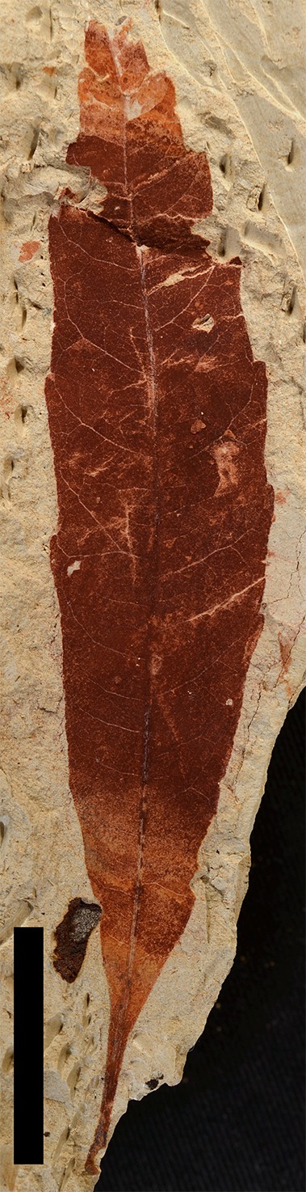
Myrica lignitum
Πιτσίδια Ηρακλείου Κρήτης
Ανώτερο Μειόκαινο
Η κλίμακα αντιστοιχεί σε 1cm

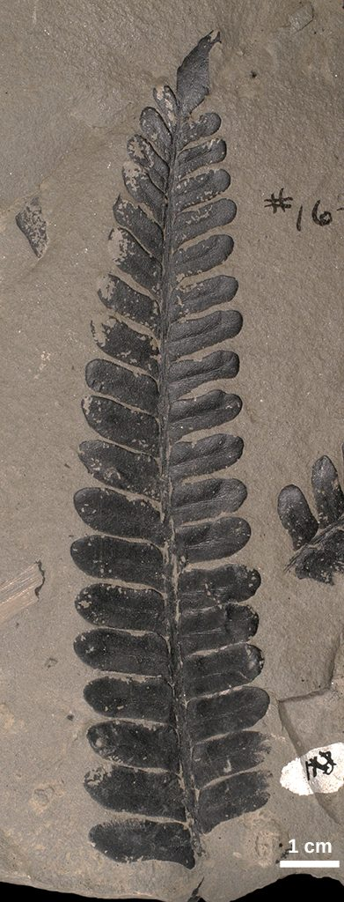
Neuropteris sp.
OPC 3016-1475
Tulsa County, Oklahoma
Λιθανθρακοφόρο

Betula similis (Göppert) Zastawniak et Walther,
SF.B 11805,
Frankfurt, Germany
Πλειόκαινο

ΙΧΝΟΑΠΟΛΙΘΩΜΑΤΑ
Ίχνη βάδισης https://sketchfab.com/3d-models/dinosaur-footprint-grallator-sp-pri-40798-15b094475f43489fa8092d2a696c3044

Ίχνη βάδισης https://sketchfab.com/3d-models/vertebrate-grallator-footprint-pri-49745-3919e764adba4eb8bceed24c260e974e

Ίχνη διατροφής https://sketchfab.com/3d-models/bivalve-ostrea-coxi-pri-40844-e6938b1c171d48ef8113bfcd9e7e3d9b

Κοπρόλιθοι https://sketchfab.com/3d-models/trace-fossil-coprolite-pri-76856-1fc7f88b0d284a238adb7c44d78011f7

Ερώτημα 2
Αρτίγονο | Απολιθωμένο
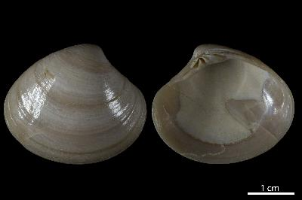 | 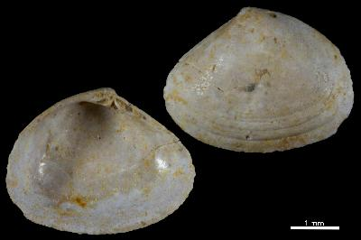
Meretrix

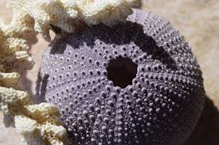 | 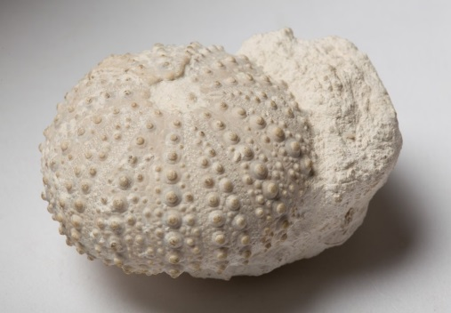
Εχινόδερμο
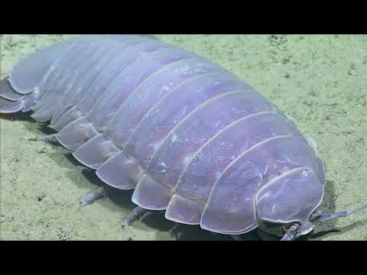 | 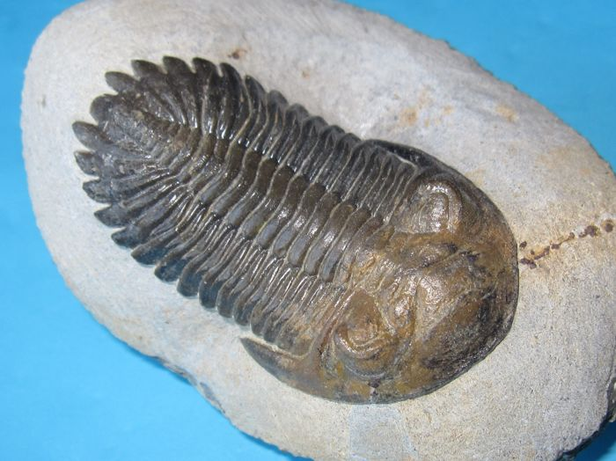
Ισόποδο | Τριλοβίτης
Ερώτημα 3
Απολίθωμα | Τρόπος απολίθωσης
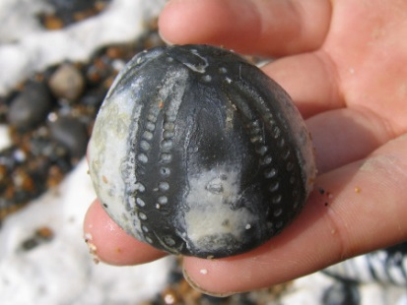 Αχινός | Λιθοποίηση
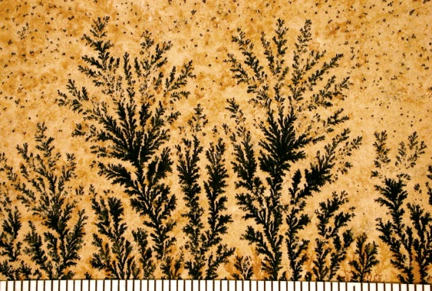 | Ψευδοαπολίθωση
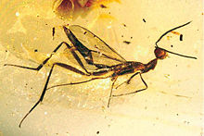 | Εγκλεισμός σε κεχριμπάρι
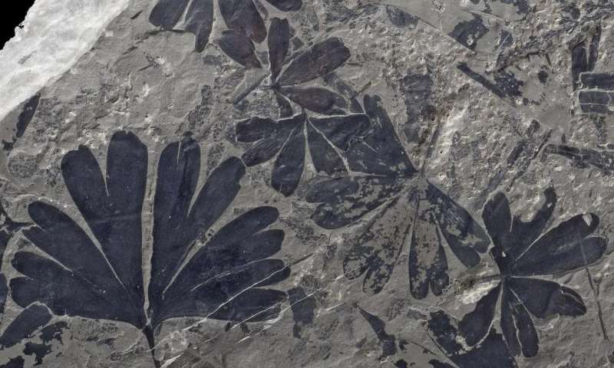 | Ενανθράκωση
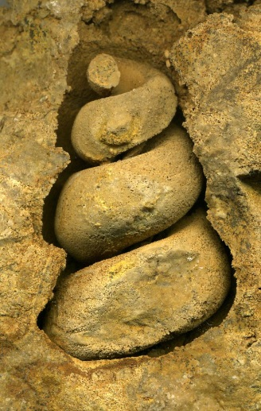 | Αποτύπωση
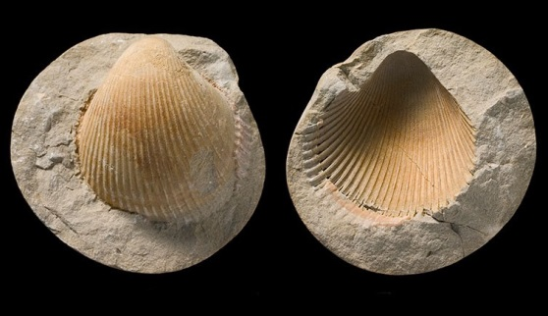 | Αποτύπωση
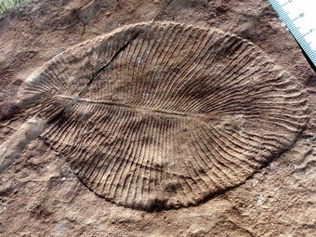 | Εκμαγείωση (πανίδα της Ediacara)
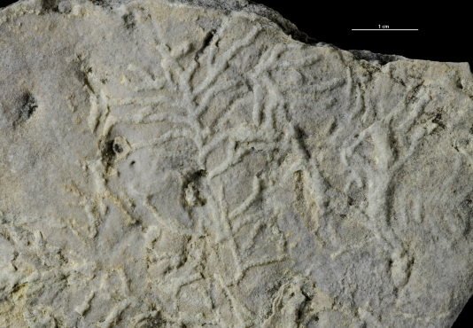 | Ιχνοαπολίθωση
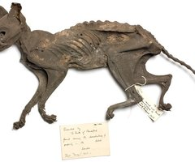 | Μουμιοποίηση
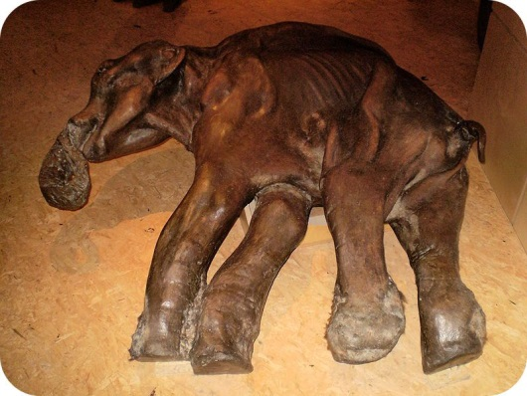 | Κατάψυξη

