The effectiveness of the ISO 9001 Quality Management System

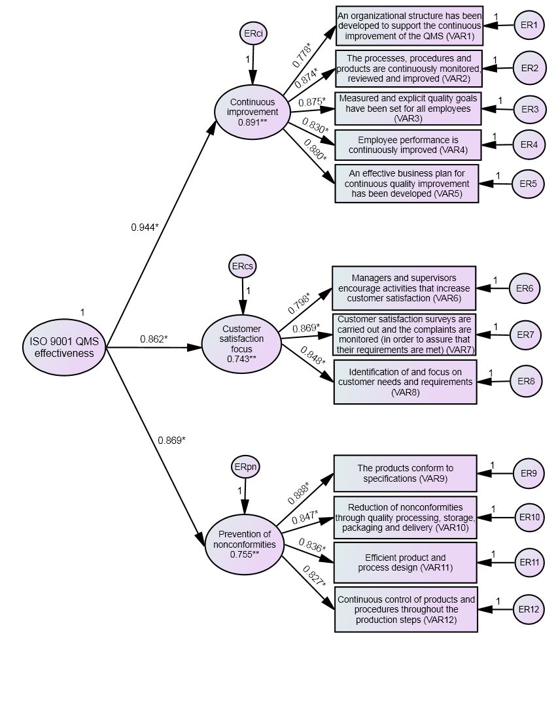

**Figure 3:** Second order CFA of the indicators of ISO 9001 objectives

*: standardized regression weight, **: squared multiple correlations.

**Table 1:** The indicators of the ISO 9001 objectives

|  |  |
| --- | --- |
| ***Indicators of “continuous improvement”*** | ***Supporting literature*** |
| An organizational structure (e.g. quality committee and circles) has been developed to support the continuous improvement of the QMS. | Conca *et al.* (2004), Marin-Garcia *et al*. (2008), Sharma and Kodali (2008) |
| The processes, procedures and products are continuously monitored, reviewed and improved. | Claver *et al.* (2002), Conca *et al*. (2004), Sadikoglu and Zehir (2010), Psomas and Fotopoulos (2010), Kumar *et al.* (2011), Psomas *et al.* (2011) |
| Measured and explicit quality goals have been set for all employees. | Zhang *et al*. (2000), Tsim *et al*. (2002), Singh *et al.* (2006) |
| Employee performance is continuously improved. | Su *et al.* (2003), Seth and Tripathi (2005), Singh *et al.* (2006) |
| An effective business plan for continuous quality improvement has been developed. | Zhang *et al*. (2000), Brah *et al*. (2002), Singh *et al.* (2006) |
| ***Indicators of “customer satisfaction focus”*** | ***Supporting literature*** |
| Managers and supervisors encourage activities that increase customer satisfaction. | Sun *et al.* (2004), Singh *et al.* (2006), Singh (2008), Sharma and Kodali (2008), Sadikoglu and Zehir (2010), Kim *et al*. (2011) |
| Customer satisfaction surveys are carried out and the complaints are monitored (in order to assure that their requirements are met). | Das (2008), Jayamaha *et al.* (2008), Lam *et al.* (2008), Sharma and Kodali (2008), Phusavat and Kanchana (2008), Ooi *et al*. (2008), Mady (2009), Anh and Matsui (2011) |
| Identification of and focus on customer needs and requirements. | Lewis *et al.* (2006), Chileshe (2007), Singh (2008), Jayamaha *et al.* (2008), Lam *et al.* (2008), Sharma and Kodali (2008), Sadikoglu and Zehir (2010), Kumar *et al.* (2011) |
| ***Indicators of “prevention of nonconformities”*** | ***Supporting literature*** |
| The products conform to specifications. | van der Spiegel *et al*. (2005), Chi *et al.* (2009), Kathuria *et al*. (2010a), Kathuria *et al*. (2010b), Avella and Vazquez-Bustelo (2010), Marin and Ruiz-Olalla (2011) |
| Reduction of nonconformities through quality processing, storage, packaging and delivery. | Chileshe (2007), Singh (2008), Brad (2008) |
| Efficient product and process design. | Lewis *et al*. (2006), Psomas *et al.* (2011) |
| Continuous control of products and procedures throughout the production steps. | Singh (2008), Chiarini (2011) |

**π**

**Π.1**

**Π.2**

**.**

**.**

**.**

**.**

**.**

**.**

**.**

**.**

**Π. ν**

**Ποιότητα**

**Προϊόντος**

**Αποτελεσματική εφαρμογή των**

**συστημάτων ποιότητας και ασφάλειας των τροφίμων**

**Λειτουργική Απόδοση**

**Q.1**

**Η.2**

**Η.3**

**Η.4**

**Η.1**

**Οικονομική απόδοση**

**Η.5**

**Κρίσιμοι παράγοντες**

**αποτελεσματικής**

**εφαρμογής**

**Η.6**

**Η.7**

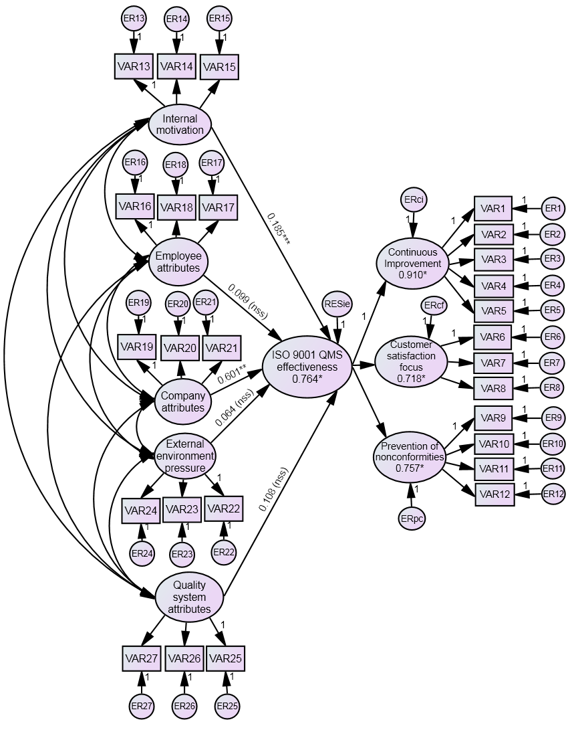

**Figure 4:** The structural model

*: R2, **: statistically significant standardized regression weight in p=0.001, ***: statistically significant standardized regression weight in p=0.01, n.s.s.: non-statistically significant.