WORLD

Migrant or Refugee? There Is a Difference, With Legal Implications
By SOMINI SENGUPTAAUG. 27, 2015
Photo
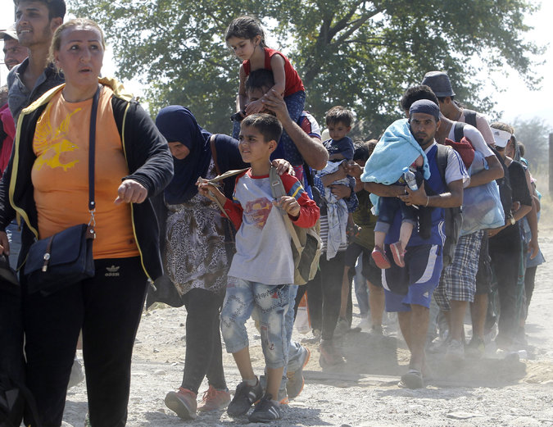
Families walked toward a center for migrants after crossing the border from Greece into Macedonia on Monday.CreditBoris Grdanoski/Associated Press
Continue reading the main storyShare This Page
- Email
- Share
- Tweet
- Save
- More
In the first half of this year alone, at least 137,000 men, women and children crossed the Mediterranean Sea to reach the shores of Europe, according to the United Nations. Thousands are traveling across the Balkans now.
Q. Does it matter what you call them?
A. Yes. The terms “migrant” and “refugee” are sometimes used interchangeably, but there is a crucial legal difference between the two.
Q. Who is a refugee?
A. Briefly, a refugee is person who has fled his or her country to escape war or persecution, and can prove it.
The 1951 Refugee Convention, negotiated after World War II, defines a refugee as a person who, “owing to a well-founded fear of being persecuted for reasons of race, religion, nationality, membership of a particular social group or political opinion, is outside the country of his nationality, and is unable to, or owing to such fear, is unwilling to avail himself of the protection of that country.”
Q. Are migrants treated differently from refugees?
A. Countries are free to deport migrants who arrive without legal papers, which they cannot do with refugees under the 1951 convention. So it is not surprising that many politicians in Europe prefer to refer to everyone fleeing to the continent as migrants.
Q. Which term applies to the flood of people reaching Europe now?
A. The United Nations refugee agency says that most of them are refugees, though some are considered migrants. “The majority of people arriving this year in Italy and Greece, especially, have been from countries mired in war or which otherwise are considered to be ‘refugee-producing,’ and for whom international protection is needed,” the refugee agency said. “However, a smaller proportion is from elsewhere, and for many of these individuals, the term ‘migrant’ would be correct.” Human traffickers make no such distinctions, though; refugees and migrants are often jammed into the same rickety boats for the crossing.
Q. How does the United States see the issue?
A. Admitting refugees is somewhat different in the United States. The State Department vets a select number of people — lately, around 70,000 a year — and admits them as refugees. Others who arrive in the country without legal papers can apply for political asylum; in that case, a judge decides on the merits of their claims.
Q. What does the distinction mean for European countries?
A. Refugees are entitled to basic protections under the 1951 convention and other international agreements. Once in Europe, refugees can apply for political asylum or another protected status, sometimes temporary. By law, refugees cannot be sent back to countries where their lives would be in danger. “One of the most fundamental principles laid down in international law is that refugees should not be expelled or returned to situations where their life and freedom would be under threat,” the refugee agency said in a statement on Thursday.
Q. Who is a migrant?
A. Anyone moving from one country to another is considered a migrant unless he or she is specifically fleeing war or persecution. Migrants may be fleeing dire poverty, or may be well-off and merely seeking better opportunities, or may be migrating to join relatives who have gone before them. There is an emerging debate about whether migrants fleeing their homes because of the effects of climate change — the desertification of the Sahel region, for example, or the sinking of coastal islands in Bangladesh — ought to be reclassified as refugees.

