**STATIC ELECTRICITY**

**WORKSHEET**



**Α. ELECTRICAL FORCES- TYPES OF ELECTRIC CHARGE**

Watch the video located at the link below

<https://edpuzzle.com/media/67209ccbeb555eb4e8aebb33>

What do you notice?

……………………………………………………………………………………………………………………………

What do you think causes the cork to pull towards the pen and the glass rod?

………………………………………………………………………………………………………………………………………………………………………………………………………………………………………………………………………………………………………………………………………………………………………………………………

Do you think that if you had not initially rubbed the pen and glass rod with the woolen fabric something would have changed and what?

……………………………………………………………………………………………………………………………………………………………………………………………………………………………………………………………..

**Experimentation**

Experimental instruments

Woolen fabric Plastic rod Rotated base

Silk Fabric Glass rod 2 pens type BIC

Experimental procedure

1. Rub one pen with woolen cloth and place it on the rotated base.

2. Rub the second pen again with woolen cloth and bring it closer (not to touch) the first pen at the end that you had rubbed with the fabric.

What do you notice?

……………………………………………………………………………………………………………………………

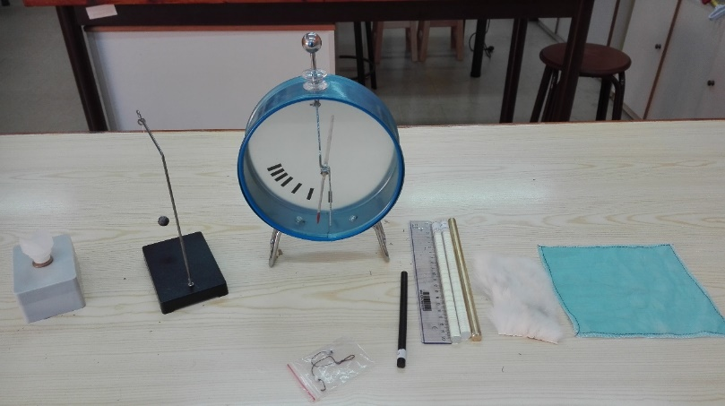

3. Rub the plastic rod with woolen fabric and place it on the rotating base.

4. Rub the glass rod with the silk fabric and bring it closer to the plastic rod at the end that you had rubbed with the woolen cloth.

What do you notice?

……………………………………………………………………………………………………………………………..

What do you think causes the pen to rotate on the base in both cases?

…………………………………………………………………………………………………………………………………………………………………………………………………………………………………………………………

Do you think that if you hadn't initially rubbed the bars with wool/silk fabric something would have changed and what? ………………………………………………………………………………………………………………………………………………………………………………………………………………………………………………………..

**Conclusion**

Between the bars …………………………….. ………………………………… are applied.

The ……………………… …………………………. with which two electrified bodies interact sometimes are ……………………. and sometimes …………………………………………………..

**B. ELECTRIFICATION METHODS**

**Electrification by friction**

Experimental Procedure

1. Rub a plastic pen with woolen cloth. Approach it to the electric pendulum

What do you notice? ………………………………………………………………………………………

What kind of charge does the pen acquire? ……………………………………………………

What kind of charge does the fabric acquire? …………………………………………………

Conclusion: When rubbing a plastic body with woolen fabric ……………………………………..are transferred from the ………………… ……………………to the ………………………………………..resulting the ………………………..to be charged ………………………………………..

1. Rub a glass rod with silk cloth. Approach her to the electric pendulum.

What do you notice? ……………………………………………………………………………………

What kind of charge does the glass rob acquire? ……………………………………………

What kind of charge does the silk cloth acquire? ……………………………………………

Conclusion: When rubbing a glass rod with silk fabric…………………………………….. are transferred from the ………………… ……………………to the …………………… …………………..resulting the ………… …………….. to be charged ………………………………………..

**During electrification by friction the bodies acquire …………………………………….electric charges.**

**Electrification of conductors by contact**

Experimental Procedure

1. Rub the plastic pen with the woolen cloth and tough it on the metal sphere of the electroscope. What do you notice;

………………………………………………………………………………………………………………………………………………………………………………………………………………………………………………………..

Explain……………………………………………………………………………………………………………………………………………………………………………………………………………………………………………………………………………………………………………………………………………………………………………………………………………………………………………………………………………………………………..

**During electrification by contact the two bodies acquire …………………………………..electric charges.**

**Electrification of conductors by induction**

Experimental Procedure

1. Rub a plastic ruler with woolen cloth and approach it DO NOT TOUCH the metal sphere of the electroscope. What do you notice happening to the sheets of the electroscope? ………………………………………………………………………………………………
2. Explain.……………………………………………………………………………………………………………………………………………………………………………………………………………………………………………………………………………………………………………………………………………………………
3. Remove the charged ruler from the electroscope. What do you notice happening to the sheets of the electroscope? .........................................................................................................................................................................................................................................................
4. Why is this happening?

………………………………………………………………………………………………………………………………………………………………………………………………………………………………………………………..

Conclusion:

……………………………………………………………………………………………………………………………………………………………………………………………………………………………………………………………………………………………………………………………………………………………………………………..

**Γ. CALCULATION OF ELECTRICAL FORCE**

Open the simulation: [**http://photodentro.edu.gr/lor/handle/8521/1649**](http://photodentro.edu.gr/lor/handle/8521/1649)

In the simulation environment you notice that there are two spheres (charges) at some distance as well as two digital charge meters q1 and q2. You can change the values of q1 and q2 and automatically the program calculates the value of the force exerted between them. The distance r between the spheres changes by moving each sphere.

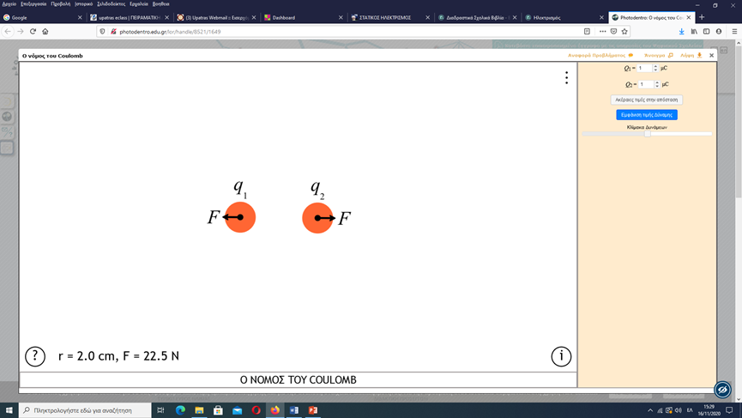

**Activity 1: Dependence of the direction of the electrostatic force on the type of charges.**

1. Reset the Q1 and Q2 counters. The force F between them is: ……………………………………………………….

2. Select Q1=0μC and Q2=2μC at a distance of 2cm.

What do you notice about the value of F? …………………………………………

3. Choose two positive electric charges Q1=1μC and Q2=2μC at a distance of 2cm.

- The measure of the force exerted in Q1 is ……………….. and in Q2 it is……………………...

- What do you observe about the **direction** of the forces F between the two electric charges? …………………………………………………….

- The vectors representing the forces are located in the ………………….. that connects the two charges.

4. Choose two negative electric charges Q1=-1μC and Q2=-2μC while keeping the distance equal to 2cm.

- The measure of the force exerted in Q1 is ……………….. and in Q2 it is……………………...

- What do you observe about the **direction** of the forces F between the two electric charges? …………………………………………………….

5. Choose one charge to be positive Q1=1μC and the other Q2=-2μC keeping the distance constant equal to 2cm.

- What do you observe about the **direction** of the forces F between the two electric charges? …………………………………………………….

- The vectors representing the forces are located in the ………………….. that connects the two charges.

6. Studying steps 3,4,5 fill in the blanks in the following sentences:

α. The direction of forces between two…………………….. electric charges is repulsive, while between two opposite electric charges is…………………………….

β. The measure of forces between two electric charges is……………….... This is a consequence of………… Newton's law (action-reaction).

**Activity 2**: **Dependence of the electrostatic force on the values of electric charges.**

7. Select Q1=1μC, Q2=4μC and distance between them r=2cm

-The force exerted in Q1 is…………...and in Q2 it is……………………………

8. With Q1=1μC and the distance r=2cm, halve Q2, i.e. Q2=2μC

-The force exerted in Q1 is…………….and in Q2 it is………………………..

-The force exerted from Q1 to Q2 and vice versa:

α. Halved

β. Doubled

γ. Remained stable

δ. None of the above

Choose the correct answer.

9. With Q1=1μC and the distance r=2cm, make Q2=1μC

-The force exerted in Q1 is……………..and in Q2 it is………………………

-The force exerted from Q1 to Q2 and vice versa:

α. Becomes four times smaller

β. Becomes four times larger

γ. Remained stable

δ. None of the above

Choose the correct answer.

**1st Conclusion**

**The electric force is …………………….. to the electric charge of each sphere and therefore to the product of charges, as long as the distance of the spheres remains ……………………**

**Activity 3:** **Dependence of the electrostatic force of the distance between the two charges.**

10. Select Q1=2μC, Q2=2μC and distance between them r=1cm

- The force exerted in Q1 is………….... and in Q2 it is………………………..

11. With Q1=2μC and Q2=2μC, double the distance r, i.e. r=2cm

- The force exerted in Q1 is………….... and in Q2 it is………………………..

- The force exerted from Q1 to Q2 and vice versa:

α. Becomes 2 times smaller

β. Becomes 4 times smaller

γ. Remained constant

δ. None of the above

Choose the correct answer.

12. With Q1=2μC and Q2=2μC, triple the distance r, i.e. r=3cm

- The force exerted in Q1 is………….... and in Q2 it is………………………..

- The force exerted from Q1 to Q2 and vice versa:

α. Becomes 3 times smaller

β. Becomes 9 times smaller

γ. Remained constant

δ. None of the above

Choose the correct answer.

**2nd Conclusion**

The electric force is ………………… ……………………… to the square of the distance between the two charges, since the charges remain …………………….....

**Conclusions 1 and 2 constitute Coulomb's law.**

**Δ. ELECTRIC FIELD**

Open the simulation:

<https://www.seilias.gr/images/stories/html5/electricFieldVoltage.html>

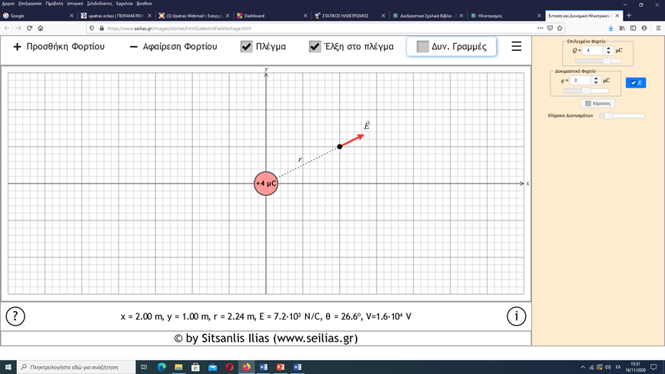

In the simulation environment you notice that there is a sphere, whose electric charge we can change with the digital charge meter Q and a point in space which is distance r from the charge Q. At this point, the electric field vector E is drawn.

**Activity 1: Dynamic electric field lines**

1. Select electrical charge (source) Q = 4μC (positive) and click on the box «Δυν. Γραμμές».

The dynamic lines are……………………………… point-facing………………..

Select electric charge (source) Q = - 4μC (negative).

The dynamic lines are……………………………… point-facing………………..

Observe the intensity vector E in both cases.

**Conclusion:** The vector E has the ..................................... of the dynamic lines.

**Activity 2: Dependence of the value E of the electric field on Q.**

First select charge Q=2 μC and distance r=2.24 m. The intensity E has a measure: ………………… Double the charge Q while keeping the distance r constant. The value of E is:………………………….

**Conclusion:** The value of the electric field Ε is…………………………………..to the charge Q that causes the electric field.

**Activity 3: Dependence of the value E of the electric field on the distance r of a point from the charge Q causing the field.**

Select charge Q=2 μC.

Drag the point of the field (the dot) onto the x-axis so that x=2.0 m and y=0.0. So r=2.0 m. The value of E is: ………………………….

Make 2 times smaller the distance r, keeping the electric charge Q constant. The value of is: ………………………….

**Conclusion:** The value of the intensity Ε of the electric field is ……………….. ………………….. to the square of the distance r of one point in the field from the charge Q, since the charge Q remains ………………………..

TIME FOR QUIZZ!!!

Χρησιμοποιώντας τον παρακάτω σύνδεσμο συνδεθείτε «ζωντανά» για να απαντήσετε σε 10 ερωτήσεις πολλαπλής επιλογής.

<https://quizizz.com/join>