Title

Name Surname

This is a spring term project submitted to the course instructor by email as partial fulfillment of the requirements for completing successfully the undergraduate ERASMUS course “Applied Econometrics” ECO-421)

Course Instructor: Associate Professor Ioannis A. Venetis

School of Economic Sciences and Business Administration,
Department of Economics

Month Year

CERTIFICATION OF THE TERM PROJECT PREPARATION
“This project is submitted in accordance with the University of Patras regulations. I hereby declare that this particular project has been written by me, in order to partially fulfil the requirements of ERASMUS course

“Applied Econometrics” ECO-421

and has not been submitted to or approved by any other postgraduate or undergraduate program in Greece or abroad. This term project presents my personal views on the subject. All the sources I have used for the preparation of this particular term project are mentioned explicitly with references being made either to their authors, or to the URL’s (if found on the internet).”

[STUDENT’S FULLNAME] [SIGNATURE]

Contents
1. Introduction 4
2. Question 1(i) 6
2.1. The model 6
2.1.1. Identification 7
2.1.2. Estimation results 8
2.2. Testing 9
3. Concluding remarks 11
References 12

1. Introduction
Contrary to popular belief, Lorem Ipsum is not simply random text. It has roots in a piece of classical Latin literature from 45 BC, making it over 2000 years old. Richard McClintock, a Latin professor at Hampden-Sydney College in Virginia, looked up one of the more obscure Latin words, consectetur, from a Lorem Ipsum passage, and going through the cites of the word in classical literature, discovered the undoubtable source. Lorem Ipsum comes from sections 1.10.32 and 1.10.33 of "de Finibus Bonorum et Malorum" (The Extremes of Good and Evil) by Cicero, written in 45 BC. This book is a treatise on the theory of ethics, very popular during the Renaissance. The first line of Lorem Ipsum, "Lorem ipsum dolor sit amet..", comes from a line in section 1.10.32.
The standard chunk of Lorem Ipsum used since the 1500s is reproduced below for those interested. Sections 1.10.32 and 1.10.33 from "de Finibus Bonorum et Malorum" by Cicero are also reproduced in their exact original form, accompanied by English versions from the 1914 translation by H. Rackham.

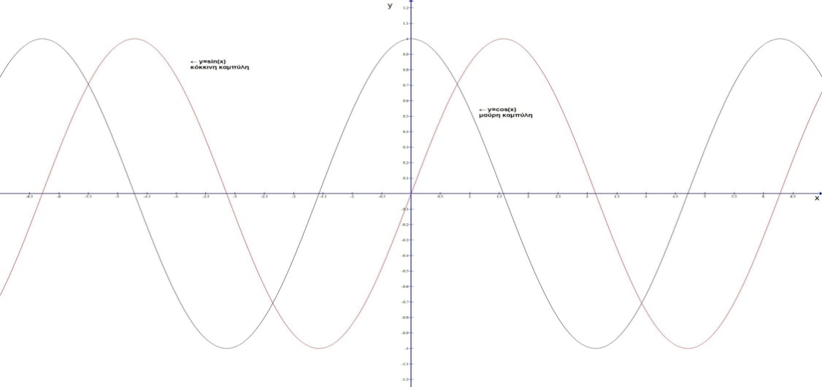
Graph 1. Trig functions.

The standard chunk of Lorem Ipsum used since the 1500s is reproduced below for those interested. Sections 1.10.32 and 1.10.33 from "de Finibus Bonorum et Malorum" by Cicero are also reproduced in their exact original form, accompanied by English versions from the 1914 translation by H. Rackham.
The standard chunk of Lorem Ipsum used since the 1500s is reproduced below for those interested. Sections 1.10.32 and 1.10.33 from "de Finibus Bonorum et Malorum" by Cicero are also reproduced in their exact original form, accompanied by English versions from the 1914 translation by H. Rackham.
The standard chunk of Lorem Ipsum used since the 1500s is reproduced below for those interested. Sections 1.10.32 and 1.10.33 from "de Finibus Bonorum et Malorum" by Cicero are also reproduced in their exact original form, accompanied by English versions from the 1914 translation by H. Rackham.

2. Question 1(i)

2.1. The model
This is a text example. This is a text example this is a text example this is a text example this is a text example this is a text example, this is a text example this is a text example this is a text example. This is a text example. This is a text example this is a text example this is a text example this is a text example this is a text example, this is a text example this is a text example this is a text example.
Lorem Ipsum is simply dummy text of the printing and typesetting industry. Lorem Ipsum has been the industry's standard dummy text ever since the 1500s, when an unknown printer took a galley of type and scrambled it to make a type specimen book.

2.1.1. Identification
Lorem Ipsum is simply dummy text of the printing and typesetting industry. Lorem Ipsum has been the industry's standard dummy text ever since the 1500s, when an unknown printer took a galley of type and scrambled it to make a type specimen book. Lorem Ipsum is simply dummy text of the printing and typesetting industry. Lorem Ipsum has been the industry's standard dummy text ever since the 1500s, when an unknown printer took a galley of type and scrambled it to make a type specimen book. Lorem Ipsum is simply dummy text of the printing and typesetting industry. Lorem Ipsum has been the industry's standard dummy text ever since the 1500s, when an unknown printer took a galley of type and scrambled it to make a type specimen book.
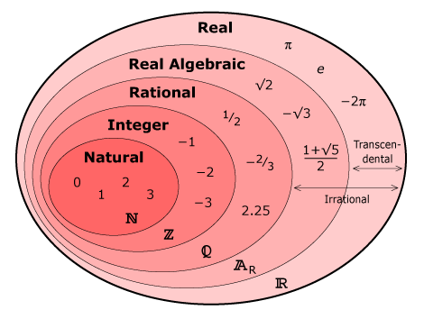
Graph 2. Another graph example.
Lorem Ipsum is simply dummy text of the printing and typesetting industry. Lorem Ipsum has been the industry's standard dummy text ever since the 1500s, when an unknown printer took a galley of type and scrambled it to make a type specimen book.

2.1.2. Estimation results
Lorem Ipsum is simply dummy text of the printing and typesetting industry. Lorem Ipsum has been the industry's standard dummy text ever since the 1500s, when an unknown printer took a galley of type and scrambled it to make a type specimen book. Lorem Ipsum is simply dummy text of the printing and typesetting industry. Lorem Ipsum has been the industry's standard dummy text ever since the 1500s, when an unknown printer took a galley of type and scrambled it to make a type specimen book.
Lorem Ipsum is simply dummy text of the printing and typesetting industry. Lorem Ipsum has been the industry's standard dummy text ever since the 1500s, when an unknown printer took a galley of type and scrambled it to make a type specimen book. Lorem Ipsum is simply dummy text of the printing and typesetting industry. Lorem Ipsum has been the industry's standard dummy text ever since the 1500s, when an unknown printer took a galley of type and scrambled it to make a type specimen book.

Case 1
Lorem Ipsum is simply dummy text of the printing and typesetting industry. Lorem Ipsum has been the industry's standard dummy text ever since the 1500s, when an unknown printer took a galley of type and scrambled it to make a type specimen book. Lorem Ipsum is simply dummy text of the printing and typesetting industry. Lorem Ipsum has been the industry's standard dummy text ever since the 1500s, when an unknown printer took a galley of type and scrambled it to make a type specimen book. Lorem Ipsum is simply dummy text of the printing and typesetting industry. Lorem Ipsum has been the industry's standard dummy text ever since the 1500s, when an unknown printer took a galley of type and scrambled it to make a type specimen book.

Case 2
Lorem Ipsum is simply dummy text of the printing and typesetting industry. Lorem Ipsum has been the industry's standard dummy text ever since the 1500s, when an unknown printer took a galley of type and scrambled it to make a type specimen book.
Below a table example
Όνομα επιστολής | Κεφαλαία γράμματα | Μικρά γράμματα | Όνομα επιστολής | Κεφαλαία γράμματα | Μικρά γράμματα
Άλφα | $$Α$$ | $$α$$ | Νι | $$Ν$$ | $$ν$$
Βήτα | $$Β$$ | $$β$$ | Χι | $$Ξ$$ | $$ξ$$
Γάμα | $$Γ$$ | $$γ$$ | Όμικρον | $$Ο$$ | $$ο$$
Δέλτα | $$Δ$$ | $$δ$$ | Πι | $$Π$$ | $$π$$
Έψιλον | $$Ε$$ | $$ε$$ | Ρο | $$Ρ$$ | $$ρ$$
Ζήτα | $$Ζ$$ | $$ζ$$ | Σίγμα | $$Σ$$ | $$σ$$
Ήτα | $$Η$$ | $$η$$ | Ταυ | $$Τ$$ | $$τ$$
Θήτα | $$Θ$$ | $$θ$$ | Ύψιλον | $$Υ$$ | $$υ$$
Γιώτα | $$Ι$$ | $$ι$$ | Φι | $$Φ$$ | $$φ$$
Κάπα | $$Κ$$ | $$κ$$ | Χι | $$Χ$$ | $$χ$$
Λάμδα | $$Λ$$ | $$λ$$ | Ψι | $$Ψ$$ | $$ψ$$
Μι | $$Μ$$ | $$μ$$ | Ωμέγα | $$Ω$$ | $$ω$$
Table 1. Table caption
Lorem Ipsum is simply dummy text of the printing and typesetting industry. Lorem Ipsum has been the industry's standard dummy text ever since the 1500s, when an unknown printer took a galley of type and scrambled it to make a type specimen book. It has survived not only five centuries, but also the leap into electronic typesetting, remaining essentially unchanged. It was popularised in the 1960s with the release of Letraset sheets containing Lorem Ipsum passages, and more recently with desktop publishing software like Aldus PageMaker including versions of Lorem Ipsum.

2.2. Testing
Lorem Ipsum is simply dummy text of the printing and typesetting industry. Lorem Ipsum has been the industry's standard dummy text ever since the 1500s, when an unknown printer took a galley of type and scrambled it to make a type specimen book. It has survived not only five centuries, but also the leap into electronic typesetting, remaining essentially unchanged. It was popularised in the 1960s with the release of Letraset sheets containing Lorem Ipsum passages, and more recently with desktop publishing software like Aldus PageMaker including versions of Lorem Ipsum.

3. Concluding remarks
Example of a mathematical formula
$$f\left(x\right)=\frac{1}{σ\sqrt{2π}}e^{-\frac{{\left(x-μ\right)}^{2}}{2σ^{2}}} , -∞<x<∞$$
can be seen above.

References

Carlos Pinho, J., Paula Rodrigues, A., & Dibb, S. (2014). The role of corporate culture, market orientation and organizational commitment to organizational performance: the case of non-profit organizations. Journal of Management Development, 33(4), 374-398.
Doherty, B., Haugh, H., & Lyon, F. (2014). Social enterprises as hybrid organizations: A review and research agenda. International Journal of Management Reviews, 16(4), 417-436.

Footnote footnote footnote.

