The effectiveness of the ISO 9001 Quality Management System

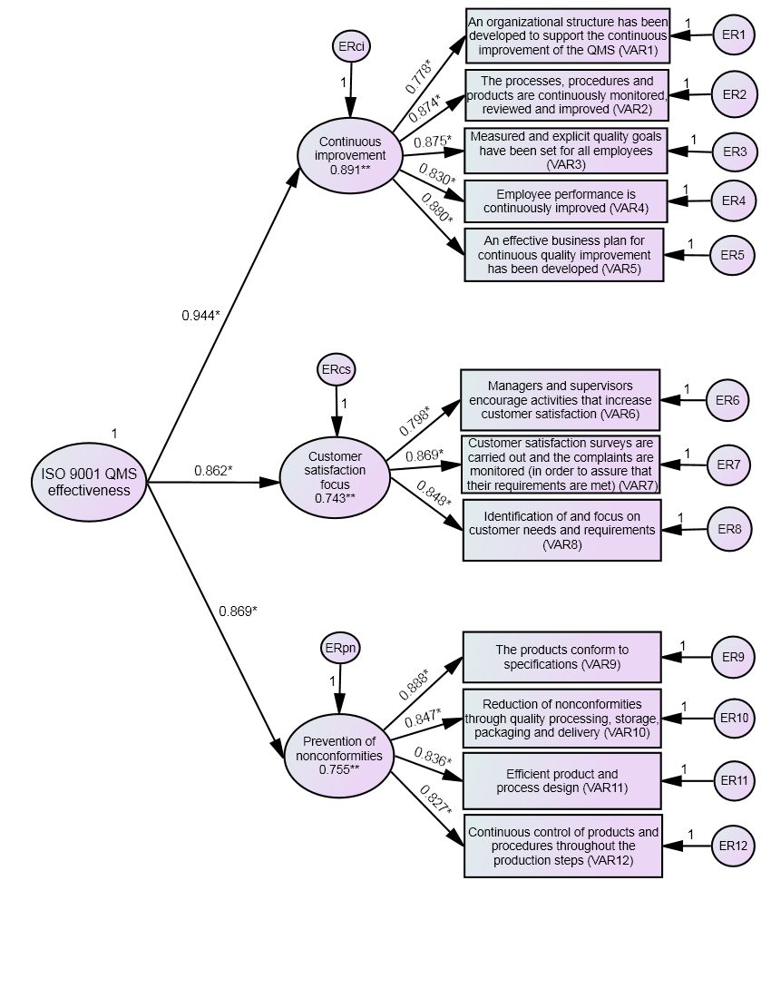
Figure 3: Second order CFA of the indicators of ISO 9001 objectives
*: standardized regression weight, **: squared multiple correlations.

π
Π.1

Π.2
.
.
.
.
.
.
.
.
Π. ν
Ποιότητα
Προϊόντος
Αποτελεσματική εφαρμογή των
συστημάτων ποιότητας και ασφάλειας των τροφίμων
Λειτουργική Απόδοση
Q.1
Η.2
Η.3
Η.4
Η.1
Οικονομική απόδοση
Η.5
Κρίσιμοι παράγοντες
αποτελεσματικής
εφαρμογής
Η.6
Η.7
Συνεχής βελτίωση
Πρόληψη μη συμμορφώσεων
Προσανατολισμός στην ικανοποίηση του πελάτη

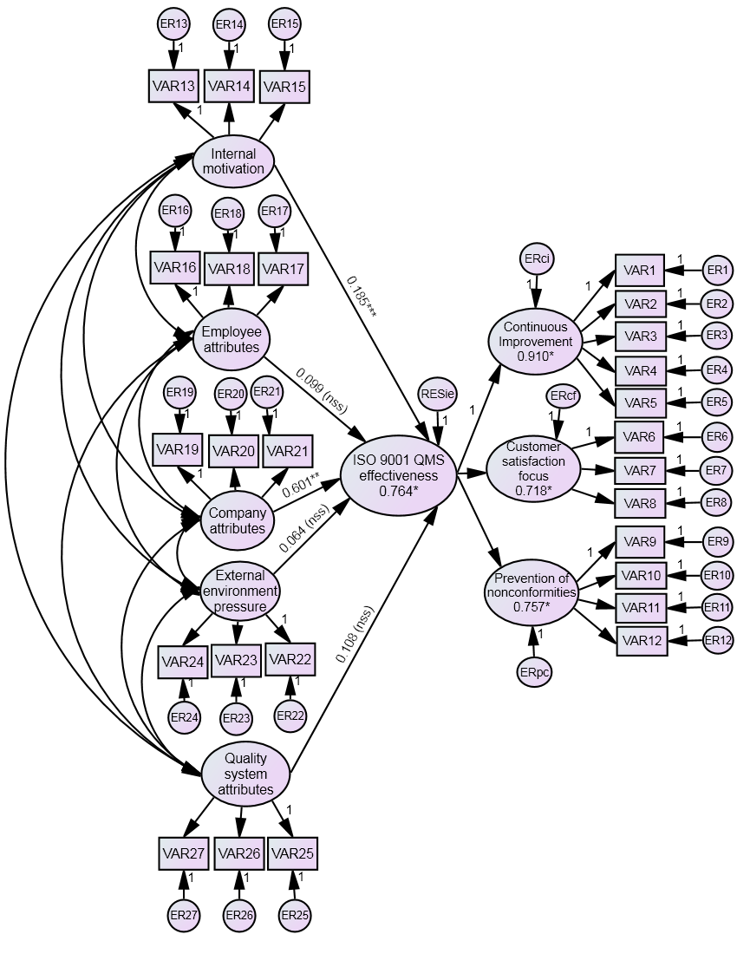
Figure 4: The structural model
*: R², **: statistically significant standardized regression weight in p=0.001, ***: statistically significant standardized regression weight in p=0.01, n.s.s.: non-statistically significant.

