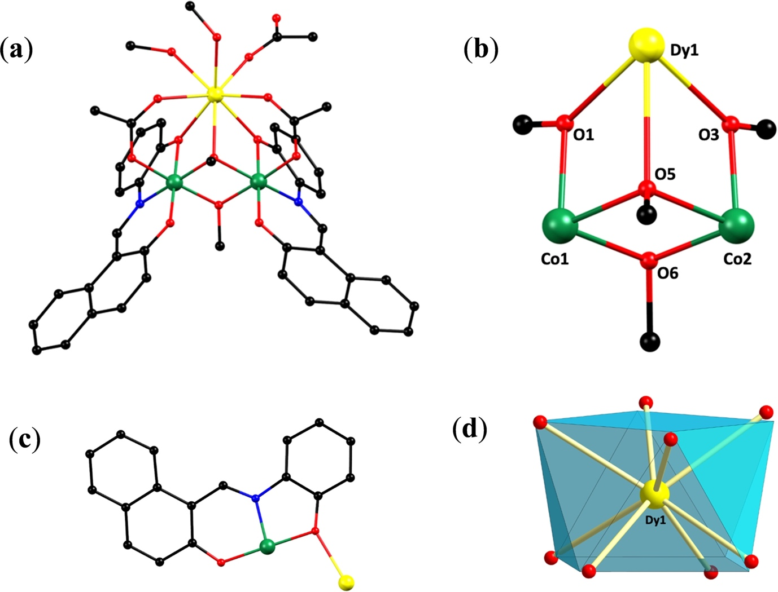

(a) Representation of the molecular structure of [Co^{III}₂Dy^{III}(OMe)₂(naph)₂(O₂CMe)₃(MeOH)₂], (b) its triangular [Co^{III}₂Dy^{III}(μ₃-OMe)(μ-OMe)(μ-OR)₂]⁵⁺ metal core, (c) the crystallographically established coordination mode of naph²⁻, and (d) the square antiprismatic coordination polyhedron of Dy. All H atoms are omitted for clarity. Color scheme: Co^{III}, green; Dy^{III}, yellow; O, red; N, blue; C, black.

